Module: Internet Technologies

Module Leader: Mr. Sumanta Silwal

**Assessment Weightage & Type**

**60% Individual Project**

**Year- 2024**

Submitted by: Drishya Bikram Pahari

Section: B

Level:3

UWE ID: 24000894

Date:12th April, 2024

Introduction

The final assignment of the module, Internet Technologies, was to prepare a portfolio website using HTML/CSS which was firstly designed using mockup. In total, I have created 5 pages, all interlinked with each other with the help of anchor tag. My portfolio consists of index.html, about.html, gallery.html, skills.html, and contact.html.

GitHub link:

Code

HTML codes :

<!DOCTYPE html>

<html lang="en">

<head>

    <meta charset="UTF-8">

    <meta http-equiv="X-UA-Compatible" content="IE=edge">

    <meta name="viewport" content="width=device-width, initial-scale=1.0">

    <title>Trial Portfolio</title>

    <link rel="stylesheet" href="style2.css">

    <link href='https://unpkg.com/boxicons@2.1.4/css/boxicons.min.css' rel='stylesheet'>

</head>

<body>

    <header class="header">

    <a href="#" class="logo"><span>Drishya Pahari</span></a>

    <nav class="navbar">

            <a href="#home">HOME</a>

            <a href="#about" >ABOUT</a>

            <a href="#gallery" >GALLERY</a>

            <a href="#skills" >SKILLS</a>

            <a href="#contact-form" >Contact</a>

        </nav>

        <a href="#contact-form" class="contact" id="contact">Contact Me</a>

    </header>

    <section class="home" id="home">

        <div class="home-content">

            <h3>Hi</h3>

            <h1>I'm <span>Drishya Pahari</span> an IT student </h1>

            <p font-size="20px">I'm an IT enthusiast also a web developer.<br>

            This is my portfolio and it the representation of all the<br>

             skills I have with the way to contact me.

            </p>

                <div class="btn-box">

                    <button class="btn-1" ><a href="#about">Know Me</a></button>

                    <button class="btn-2" ><a href="#contact-form">Hire Me</a></button>

                </div>

        </div>

        <div class="img-box">

            <img src="done again.jpg" alt="">

        </div>

    </section>

    <section class="about" id="about">

        <div class="about-img">

            <img src="ownone.jpeg" alt="">

        </div>

        <div class="about-content">

            <h2 class="heading">About <span>Me</span></h2>

            <h3>IT <span>Learner</span></h3>

            <p font-size="25px">

                I m currently studying Bsc.Hons Computing at The British College. This website <br>

                is a special project for me as it has given us so much knowledge about my course.<br>

                It will also help me to excel in my IT journey. I am living in Kathmandu and trying<br>

                my best to achieve what I can do in my life.I am a very hardworking person and I am<br>

                always ready to learn new things. I have even taken special courses of sharpen my <br>

                skills. Here are some of my projects and skills I have gained all this while.<br>

            </p>

            <a href="#skills" class="btn-2">Skills</a>

        </div>

    </section>

    <section class="skills" id="skills">

        <div class="tabit">

        <h1>My <span>Skills</span></h1>

        </div>

        <div class="table">

          <table>

            <tr>

             <b><th><b>Web Development</b></th>

              <th><b>Photoshop</b></th>

              <th><b>Cisco</b></th>

              <th><b>Kali Linux</b></th>

              <th><b>Python</b></th>

              <th><b>C/C++</b></th>

            </b>

            </tr>

            <tr>

              <td>HTML</td>

              <td>Image editing</td>

              <td>Networking</td>

              <td>Penetration testing</td>

              <td>Programming</td>

              <td>System Programming</td>

            </tr>

            <tr>

              <td>CSS</td>

              <td>Graphic Design </td>

              <td>Routing</td>

              <td>Ehical Hacking</td>

              <td>Data Analysis</td>

              <td>Libraries</td>

            </tr>

            <tr>

              <td>Javascript</td>

              <td>Photo manipulation</td>

              <td>Switching</td>

              <td>Security Auditing</td>

              <td>Machine Learning</td>

              <td>OOP</td>

            </tr>

            <tr>

              <td>PHP</td>

              <td>Logo Design</td>

              <td>Security</td>

              <td>Data 22</td>

              <td>Functions</td>

              <td>....</td>

            </tr>

            <tr>

              <td>My SQL</td>

              <td>Animation</td>

              <td>Firewalls</td>

              <td>Data 28</td>

              <td>Pandas</td>

              <td>....</td>

            </tr>

          </table>

          </div>

        </section>

        <section class="gallery" id="gallery">

            <div class="gallery-text">

            <h1><span>My</span> Images </h2>

            </div>

            <div class="gallery-images">

                <a href="#"><img src="DLOGP.jpeg" alt=""></a>

                <a href="#"><img src="EKLOOO.jpeg" alt=""></a>

                <a href="#"><img src="bhitta.jpg" alt=""></a>

                <a href="#"><img src="budhanil.jpg" alt=""></a>

                <a href="#"><img src="farewell.jpg" alt=""></a>

                <a href="#"><img src="lumbini.jpg" alt=""></a>

                <a href="#"><img src="KRISHNAh.png" alt=""></a>

            </div>

        </section>

    <section class="contact-form" id="contact-form">

        <h2 class="contact-me" >Contact <span>Me</span></h2>

        <form action="#">

            <div class="input-box">

                <input type="text" placeholder="Full Name">

                <input type="email" placeholder="Email">

            </div>

            <div class="input-box">

                <input type="text" placeholder="Phone Number">

                <input type="text" placeholder="Subject">

            </div>

            <textarea name="" id="" cols="30" rows="10" placeholder="Your Message">

            </textarea>

            <input type="submit" value="Send Message" class="btn-1">

        </form>

    </section>

    <footer class="footer">

        <div class="social">

            <a href="https://github.com/drishya254"><i class='bx bxl-github'></i></a>

            <a href="https://www.facebook.com/drishya.paharichhettri"><i class='bx bxl-facebook-circle'></i></a>

            <a href="https://www.linkedin.com/in/drishya-pahari-2a730b276/"><i class='bx bxl-linkedin-square' ></i></a>

            <a href="https://www.instagram.com/drishyapahari10/"><i class='bx bxl-instagram' ></i></a>

            <a href="https://www.gmail.com/drishyapahari@gmail.com"><i class='bx bxl-gmail'></i></a>

            <br><br>

            Phone no: +977 9805165769

        </div>

        <ul class="list">

            <li><a href="#">FAQ</a></li>

            <li><a href="#">Services</a></li>

            <li><a href="#about">About Me</a></li>

            <li><a href="#contact">Contact</a></li>

            <li><a href="#">Privacy Policy</a></li>

        </ul>

        <p class="copyright">2024 Drishya | Pahari</p>

    </footer>

</body>

</html>

CSS Codes:

*{

margin: 0;

    padding: 0;

    box-sizing: border-box;

    font-family: 'Poppins',sans-serif;

    text-decoration: none;

    list-style: none;

}

.header{

    position: fixed;

    top: 0;

    left: 0;

    width: 100%;

    padding: 10px 12%;

    background: grey;

    backdrop-filter: blur(10px);

    display: flex;

    justify-content: space-between;

    align-items: center;

    z-index: 100;

}

.logo{

    font-size: 25px;

    color: white;

    font-weight: 650;

    transition: 0.3s ease;

}

.logo:hover{

    color: orangered;

    text-shadow: 0 0 25px orangered,

                 0 0 50px orangered;

    transform: scale(1.1);

}

span{

    color: orangered;

}

.navbar a{

    font-size: 18px;

    color: white;

    font-weight: 500;

    margin: 0 20px;

    border-bottom: 3px solid transparent;

    transition: 0.3s ease;

}

.navbar a:hover,

.navbar a.active{

    color: orangered;

    border-bottom: 3px solid orangered;

}

.contact{

    padding: 10px 28px;

    background-color:black;

    color: white;

    border: 2px solid transparent;

    border-radius: 8px;

    font-size: 25px;

    letter-spacing: 1px;

    font-weight: 600;

    transition: 0.3s ease;

}

.contact-form{

    background-color: black;

}

.contact:hover{

    background-color:orangered;

    box-shadow: 0 0 25px orangered;

    color: white;

}

.home{

    width: 100%;

    min-height: 100vh;

    background: black;

    display: flex;

    align-items: center;

    gap: 7em;

    padding: 30px 12% 0;

    border-bottom: 10px solid grey;

}

.home-content{

    max-width: 800px;

    color: white;

}

.home-content h3{

    font-size: 42px;

    color: white;

}

.home-content h1{

    font-size: 62px;

    line-height: 1.2;

    color: white;

}

.home-content p{

    font-size: 25px;

    margin: 25px 0 30px;

    color: white;

}

.btn-box{

    width: 345px;

    display: flex;

    gap: 2em;

}

.btn-1{

    padding: 15px 28px;

    background-color: orangered;

    color: white;

    border: 2px solid transparent;

    border-radius: 8px;

    font-size: 18px;

    letter-spacing: 1px;

    font-weight: 600;

    transition: 0.3s ease;

    cursor: pointer;

}

.btn-1:hover{

    background-color: white;

    color: black;

    border: 2px solid black;

}

.btn-2{

    padding: 15px 28px;

    background-color: orangered;

    color: white;

    border: 2px solid black;

    border-radius: 8px;

    font-size: 18px;

    letter-spacing: 1px;

    font-weight: 600;

    transition: 0.3s ease;

    cursor: pointer;

}

.btn-2:hover{

    background-color: white;

    color: orangered;

}

.img-box img{

    position: relative;

    border-radius: 50%;

    width: 550px;

    box-shadow: 0 0 30px orangered,

                0 0 60px orangered;

}

::-webkit-scrollbar{

    width: 15px;

}

::-webkit-scrollbar-thumb{

    background-color: orangered;

}

::-webkit-scrollbar-track{

    background-color: black;

    width: 50px;

}

.about{

    display: flex;

    justify-content: center;

    align-items: center;

    padding: 12% 8%;

    gap: 10em;

    background: black;

    border-top: 10px solid grey;

    border-bottom: 10px solid grey;

}

.about-img img{

    position: relative;

    width: 550px;

    box-shadow: 0 0 25px orangered,

                0 0 50px orangered;

    border-radius: 50%;

}

.about-content h2{

    text-align: left;

    color: white;

    font-size: 42px;

}

.about-content h3{

    font-size: 62px;

    color: white;

}

.about-content p{

    color: white;

    font-size: 25px;

    margin: 2em 0 3em;

}

.skills{

background-color: black;

color: white;

padding: 12% 8%;

}

table {

    border: 5px solid rgb(12, 247, 12);

  border-collapse: collapse;

  width: 100%;

  color: white;

  padding: 5% 3%;

  align-items: center;

  text-align: center;

  font-weight:600px;

}

th, td {

  border: 3px solid rgb(12, 247, 12);

  padding: 7px;

  text-align: center;

  color: white;

  padding: 2% 2%;

  align-items: center;

  text-align: center;

  font-size: 20px;

}

.tabit{

text-align: center;

color: white;

text-size-adjust: 300px;

font-size: 40px;

padding:5px;

}

.gallery{

    color: white;

    display: flex;

    align-items: top;

    justify-content: top;

    background: black;

    border-top: 10px solid grey;

    border-bottom: 10px solid grey;

    padding: 5% 3%;

}

.gallery-text{

position: relative;

text-align: center;

padding: 5% 3%;

align-items: center;

font-size:40px;

}

.gallery-images img{

    top: 0px;

    border-top: 10px solid white;

    border-bottom: 10px solid white;

    width: 400px;

    height: 400px;

    position: center;

    object-fit: cover;

    box-shadow: 0 0 25px orangered,

                0 0 50px orangered;

    border-radius: 5%;

}

.contact-form h2{

    text-align: center;

    margin-top: 3em;

    margin-bottom: 1em;

    font-size: 36px;

    background-color: black;

    color: white;

}

.contact-form form{

    max-width: 50em;

    margin: 1em auto;

    text-align: center;

    margin-bottom: 3em;

    background-color: black;

    color: white;

}

.contact-form form .input-box{

    display: flex;

    justify-content: center;

    flex-wrap: wrap;

    background-color: white;

    color: black;

}

.contact-form form .input-box input,

.contact-form form textarea{

    width: 100%;

    padding: 1.5em;

    font-size: 18px;

    background-color: white;

    color: black;

    background: balck;

    border-radius: .8rem;

    margin: 1rem 0;

    resize: none;

}

.footer{

    position: relative;

    bottom: 0;

    width: 100%;

    padding: 40px 0;

    background-color: black;

}

.footer .social{

    text-align: center;

    padding-bottom: 25px;

    color: white;

}

.footer .social a{

    font-size: 24px;

    color: white;

    border: 2px solid orangered;

    width:40px;

    height: 40px;

    line-height: 38px;

    display: inline-block;

    text-align: center;

    border-radius: 50%;

    margin: 0 8px;

    box-shadow: inset 0 0 10px orangered, 0 0 10px orangered;

    transition: 0.3s ease;

}

.footer .social a:hover{

    transform: scale(1.2)translateY(-10px);

    color: orangered;

    border: 2px solid orangered;

}

.footer ul{

    margin-top: 0;

    padding: 0;

    font-size: 18px;

    line-height: 1.6;

    margin-bottom: 0;

    text-align: center;

}

.footer ul li a{

    color: white;

    border-bottom: 1px solid transparent;

    transition: 0.3s ease;

}

.footer ul li a:hover{

    border-bottom: 3px solid orangered;

}

.footer ul li{

    display: inline-block;

    padding: 0 5px;

}

.footer.copyright{

    margin-top: 15px;

    text-align: center;

    font-size: 12px;

    color: white;

}

FINAL PORTFOLIO

Page 1: Home Page

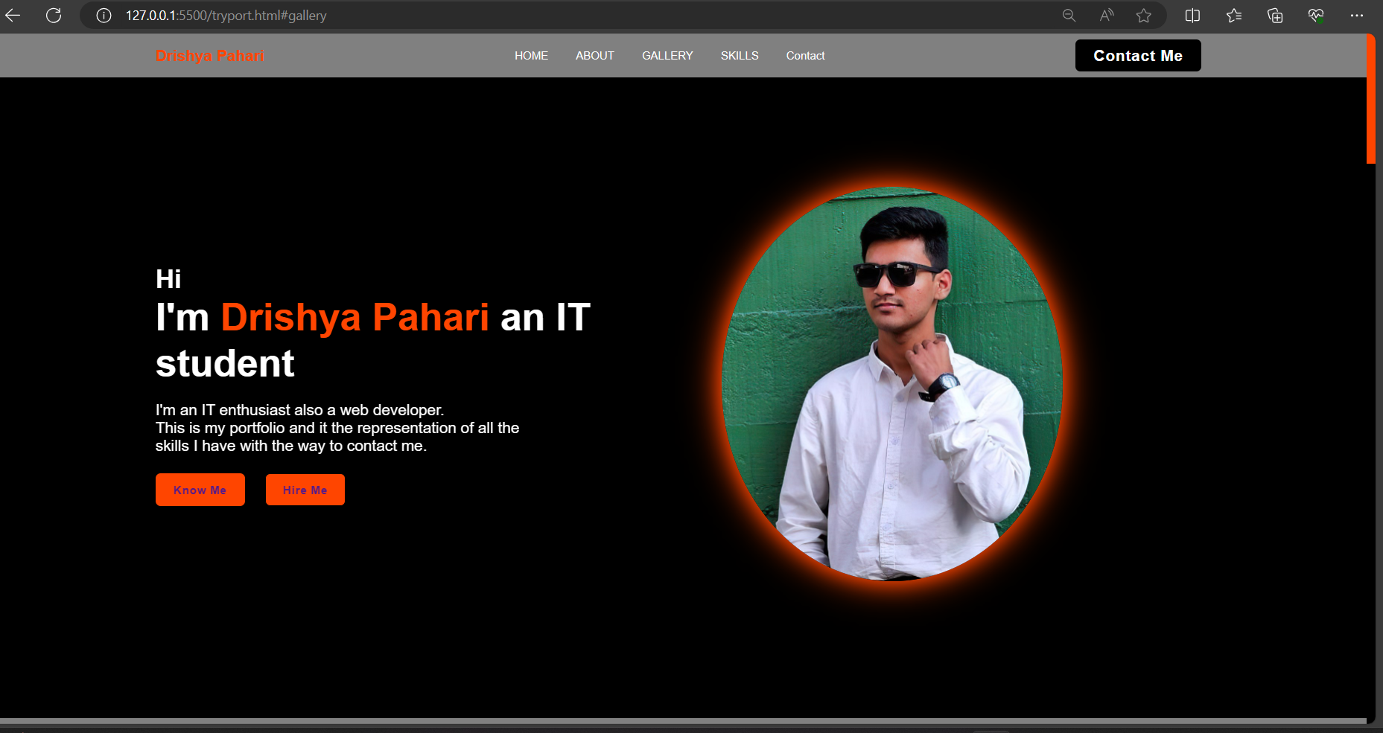

Page 2- About Me:

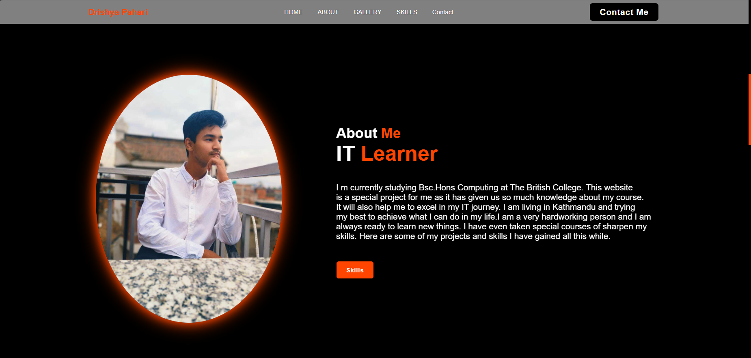

Page 3- Skills:

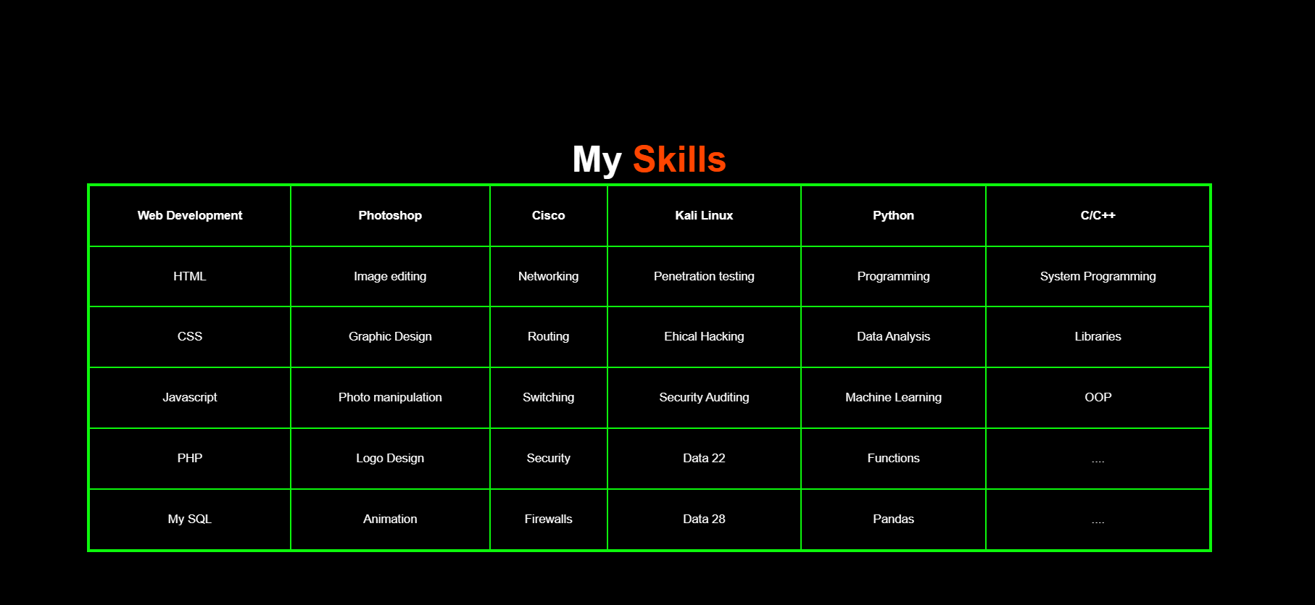

Page 4- Gallery:

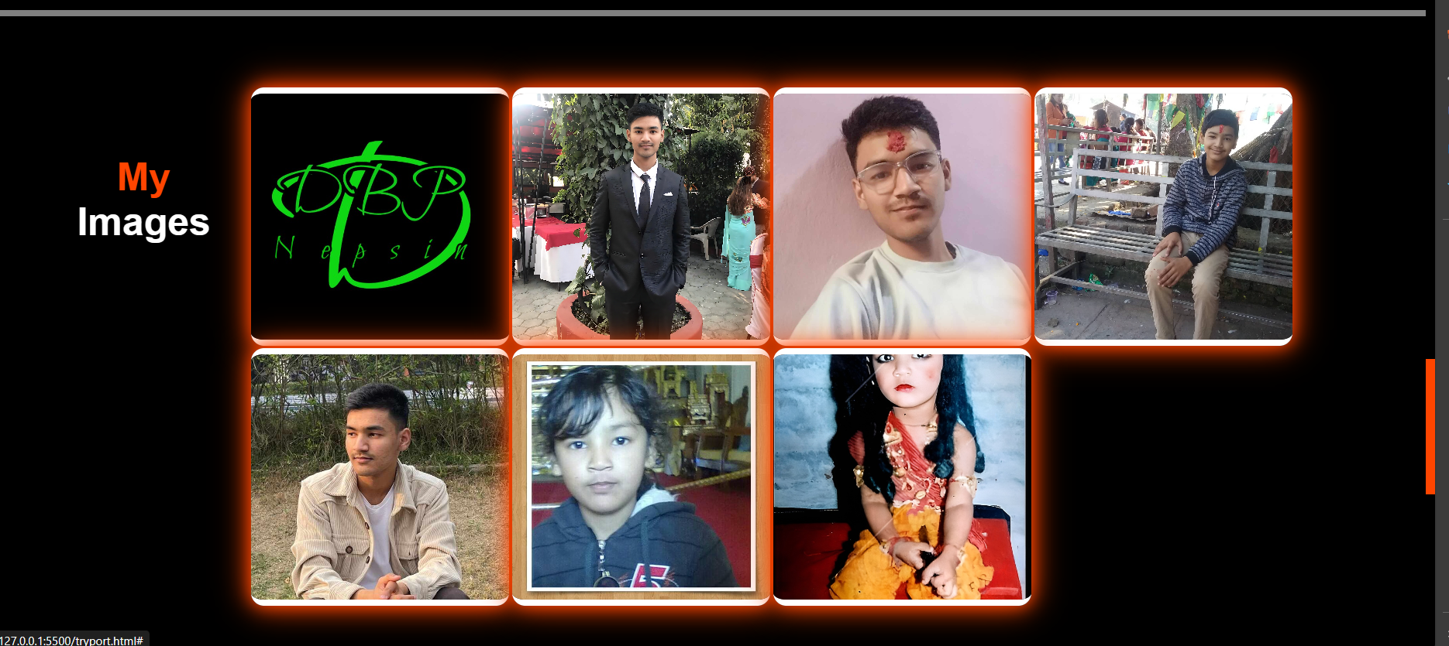

Page 5- Contact:

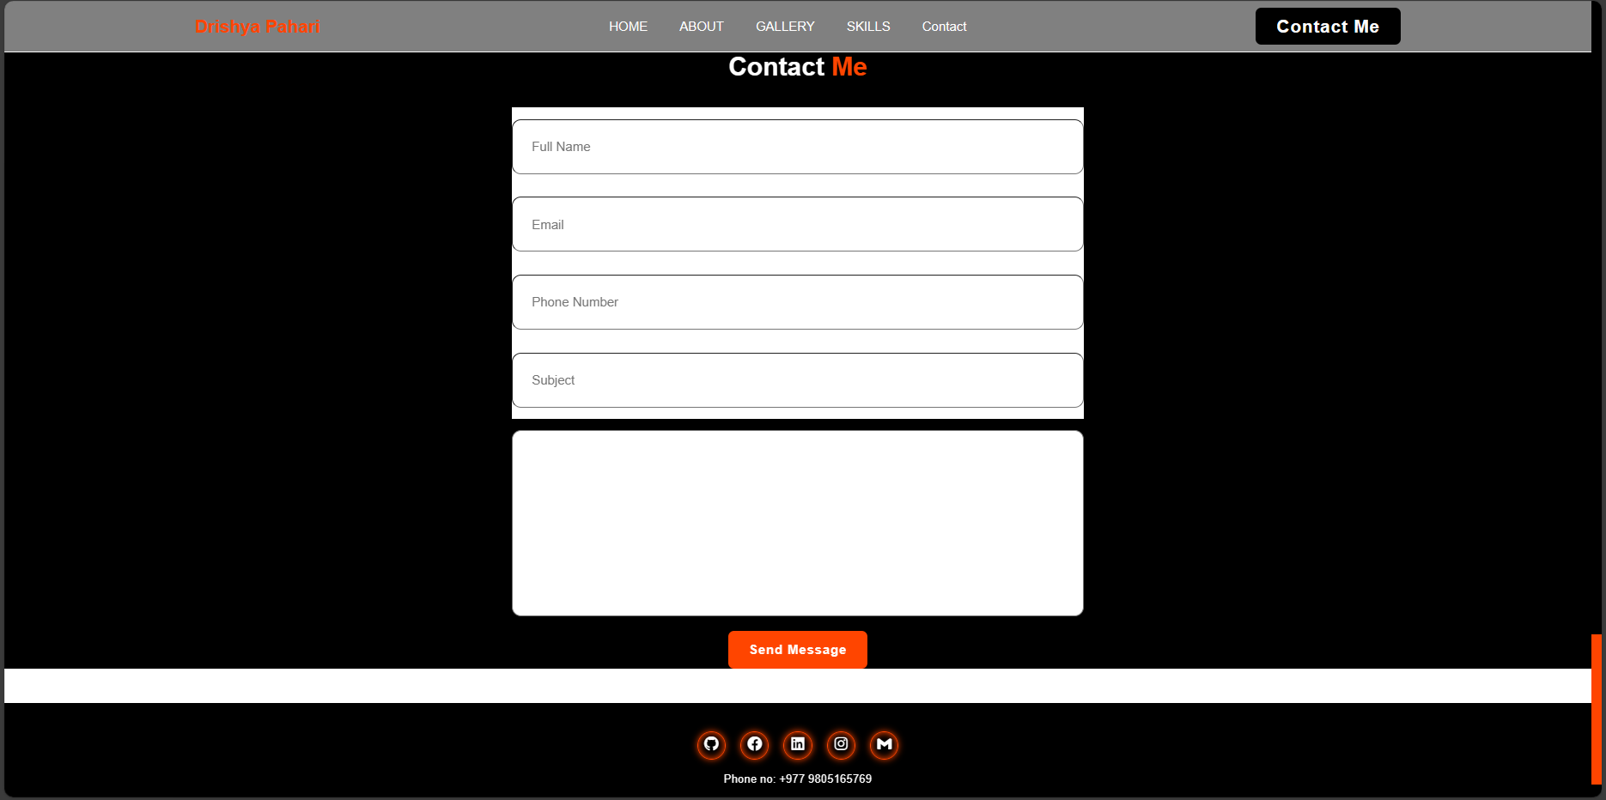

Code description: My portfolio consists of five pages namely (Home, About, Skills, Gallery, Contact). I have chosen a dark theme for this project. There is a header file which consists of my name and topics . When you hover your mouse over them it shines in orangered color. The website is made very user friendly as it is easier to navigate through the pages. I have used a table in the place of skills. For the borders in the images I have used a orangered shadow.

GitHub repository link -